COAL LAB 3

QUESTION 1
CODE
include Irvine32.inc
.data
output dword 25
string byte "The output is:",0
.code
main proc
mov edx, OFFSET string
call writestring
mov eax,output
call writeint
ret
main endp

end main

OUTPUT
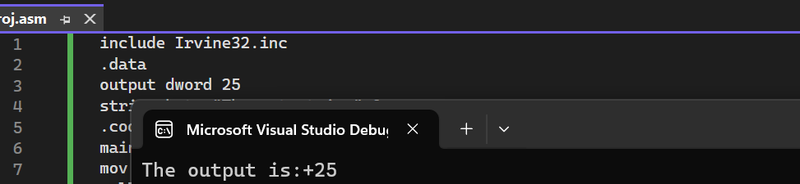
QUESTION 2
CODE
include Irvine32.inc
.data
a dword 10
b dword 20
string byte "a+b is:",0
.code
main proc
mov edx, OFFSET string
call writestring
mov eax,a
add eax,b
call writeint
ret
main endp

end main

OUTPUT
QUESTION 3
CODE
include Irvine32.inc
.data
x sdword 50
y sdword 15
string byte "y-x is:",0
.code
main proc
mov edx, OFFSET string
call writestring
mov eax,y
sub eax,x
call writeint
ret
main endp

end main

OUTPUT

QUESTION 4
CODE
include Irvine32.inc
.data
a sdword 8
b sdword 4
c1 sdword 2
string byte "a+b-c=",0
.code
main proc
mov eax,a
add eax,b
sub eax,c1
mov edx, offset string
call writestring
call writeint

main endp
end main
OUTPUT

QUESTION 5
CODE
include Irvine32.inc
.data
array db 5 dup(0)

.code
main proc
mov byte ptr [array],1
mov byte ptr [array+1],2
mov byte ptr [array+2],3
mov byte ptr [array+3],4
mov byte ptr [array+4],5

mov eax,0
mov al,array[0]
call writeint
call crlf
mov eax,0
mov al,array[1]
call writeint
call crlf
mov eax,0
mov al,array[2]
call writeint
call crlf
mov eax,0
mov al,array[3]
call writeint
call crlf
mov eax,0
mov al,array[4]
call writeint
call crlf

main endp
end main
OUTPUT
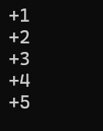
QUESTION 6
CODE
include Irvine32.inc
.data
array db 5 dup(5)
string1 byte "Every element has the value of 5",0
string2 byte "for example, the [3]rd element has value of:",0

.code
main proc
mov edx, offset string1
call writestring
call crlf
mov edx, offset string2
call writestring

mov eax,0
mov al,array[3]
call writeint

main endp
end main
OUTPUT
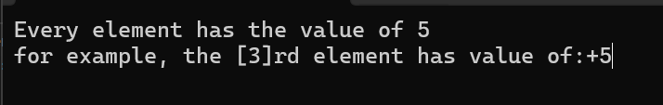
QUESTION 7
CODE
include Irvine32.inc
.data
array dword 5,10,15,20,25
string byte "The sum of all elements is:"
.code
main proc
mov eax,array[0]
add eax,array[1]
add eax,array[2]
add eax,array[3]
add eax,array[4]

mov edx,offset string
call writestring
call writeint
main endp
end main
OUTPUT
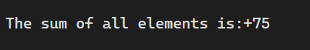
QUESTION 8
CODE
include Irvine32.inc
.data
a sdword 3
b sdword 4
c1 sdword 2
string byte "a+b-c=",0
.code
main proc
mov eax,a
add eax,b
sub eax,c1
mov edx, offset string
call writestring
call writeint

main endp
end main
OUTPUT
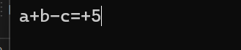
QUESTION 9
CODE
include Irvine32.inc
.data
x sbyte 4
y sbyte 3
z sbyte 2
w sbyte 5
string byte "(x+y)+(z+w)-(y+z)="
.code
main proc
mov eax,0
add al,x
add al,y
add al,z
add al,w
sub al,y
sub al,z
call writeint
main endp
end main

OUTPUT
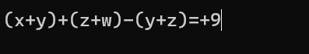
QUESTION 10
CODE
include Irvine32.inc
.data
m sbyte 10
n sbyte 5
p sbyte 2
q sbyte 3
string byte "(m-n)+(p+q)-(m-q)="
.code
main proc
mov eax,0
add al,m
sub al,n
add al,p
add al,q
sub al,m
add al,q
call writeint
main endp
end main
OUTPUT
